Kisan Sahayak: An AI Powered Framework for Subsidy Recommendation for Farmers in India

¹Dhruvi Bharat Patel, ²Sunita Jena
¹Department of M.Sc. Big Data Analytics, Jai Hind College, Mumbai, India
²Department of IT, Jai Hind College, Mumbai, India
¹dhruvipatelb3110@gmail.com
²sunita.jena@jaihindcollege.edu.in

Abstract—Access to government agricultural subsidies in India is a significant challenge for farmers, hindering their economic stability. The critical information for these schemes is often fragmented across numerous, complex, and difficult-to-navigate central and state government portals. This fragmentation creates a severe information asymmetry, where many farmers are unaware of the benefits they are eligible for, miss application deadlines, or struggle with complex eligibility criteria. Consequently, the utilization of these beneficial schemes remains sub-optimal.This research paper proposes the design, development, and evaluation of "Project Kisan Sahayak," an AI-powered framework to address this problem. The core of this project is a conversational AI assistant built upon a Retrieval-Augmented Generation (RAG) architecture. This methodology is specifically chosen to ensure the information provided to the farmer is both accurate and trustworthy, mitigating the risk of AI "hallucinations."The proposed system will first retrieve factual, up-to-date information from a curated knowledge base of official government subsidy documents. This retrieved context will then be fed to a large language model, which will generate a simple, easy-to-understand, and personalized response to the farmer's query in their natural language. The primary objective of this research is to build and test a functional prototype of this RAG-based system, demonstrating its feasibility as a scalable tool.This work aims to provide a significant contribution by designing a system that can act as a reliable digital bridge. "Kisan Sahayak" will empower farmers by providing instant, 24/7 access to clear and accurate subsidy information, ultimately aiming to increase the uptake of government schemes and support the financial empowerment of the Indian agricultural community.
Keywords—Indian Agriculture, Agricultural Subsidies, Farmers, Government schemes, Information Asymmetry, Farmer Empowerment, Artificial Intelligence, Retrieval-Augmented Generation (RAG), Large Language Models (LLMs), Conversational AI
- Introduction
Agriculture is the backbone of India’s economy that provides livelihood to nearly 58% of the population and contributing about 19.9% to the GDP in 2023-24 [3]. Around 85% of the farmer have less than 2 hectares of land and manages about 45% of the agricultural land of India and majority of the farmers’ income is very low [9]. The agriculture sector struggles with several persistent challenges such as growing input costs, environmental stress, etc. In order to support farmers and boost productivity, the Government of India has established wide range of subsidy system that includes support for fertilizers, irrigation, electricity, credit and much more. In the Union Budget of the year 2024-25, the government set aside a substantial ₹4 trillion (around $48 billion) for agricultural subsidies out [3].
Agricultural subsidies are financial assistance or benefits given by the government to farmers, agri-business, or agricultural organizations to promote economic development and social equity. It is used to supplement their income by reducing their input cost, stabilise prices, ensure food security and protect them from volatile market and weather conditions. Agricultural subsidies constitute about 2% of India’s GDP. Total subsidy to farmers’ amount to 21% of their farm income, according to Ministry of Agriculture and Farmer Welfare [1]. However, the existence of subsidies does not automatically translate into access or utilization due to poor targeting and administrative leakages. The central challenge is not policy absence, but information access failure. In recent years, the increasing availability of digital technologies in rural areas has created new possibilities for improving access to agricultural support systems. However, significant gaps remain between the availability of digital services and farmers’ ability to use them effectively. Understanding these structural and informational challenges is essential for designing more accessible and efficient agricultural support mechanisms.
- Literature review
Agricultural subsidies have been widely studied as a key policy instrument for supporting agricultural development and improving rural livelihoods. In India, subsidy programmes have played an important role in stabilizing farm incomes and promoting the adoption of modern agricultural practices. At the same time, researchers and policy analysts have highlighted several economic, institutional, and environmental challenges associated with the existing subsidy system. Understanding the evolution and structure of agricultural subsidies is therefore essential for evaluating their effectiveness and identifying areas for improvement.
- Agricultural Subsidies in India: A Structural and Historic Overview
Agricultural subsidies in India are majorly categorized into three main types- Direct, Indirect and Output subsidies.
1. Direct subsidies are the ones which provide direct monetary support to farmers with the objective of improving their income and reducing dependency on intermediaries implemented through Direct Benefit Transfer (DBT). Example: Pradhan Mantri Kisan Samman Nidhi (PM-KISAN). It provides an income of ₹6,000 per year to eligible farmer families in three equal instalments [1], [6].
2. Indirect subsidies are the subsidies which reduce the cost of agricultural production by reducing the price of inputs required. This category covers a wide range of sub categories like fertilizer, seed, irrigation, electricity, farm mechanization, solar, credit, insurance, etc. [1], [4], [6].
3. Output and Market Linked subsidies, this category operates post production to protect farmers from volatile market and ensure reasonable prices. This includes the Minimum Support Price, Infrastructure & Post-Harvest subsidies to export subsidies [7].
The development of agricultural subsidies in India has gradually shifted from ensuring food security to addressing broader economic and environmental concerns. In the years after independence, government efforts focused mainly on stabilizing agriculture through institutional measures such as the introduction of Minimum Support Prices and the establishment of procurement systems like the Food Corporation of India. With the Green Revolution in the 1960s and 1970s, subsidies expanded significantly to promote the use of high-yielding seeds, fertilizers, and irrigation, helping increase production but also creating long-term dependence on input support. During the 1980s and 1990s, these subsidy systems became deeply entrenched, leading to rising fiscal costs as well as environmental issues such as groundwater depletion and soil degradation, with larger farmers often benefiting more than smallholders. Since the 2000s, policy efforts have increasingly focused on making subsidies more efficient and sustainable, particularly through income-support programs such as direct benefit transfers and initiatives promoting improved water management and resource conservation [4].
- Critical Assessment of Current Subsidy System
Agriculture remains a primary source of rural employment, and subsidies help sustain rural livelihoods by improving access to modern technology and equipment, thereby enhancing productivity and supporting overall rural development [4]. The current subsidy regime in India faces several structural weaknesses that affects both fiscal stability and agricultural sustainability. An increasing volume of subsidies and recurring farm loan waivers leads to burden on government finances and at the same time poorly targeted subsidies encourage the overuse and misuse of critical resources such as low cost fertilizers like urea are used in excessive quantity [1], [2], [4], [7], [8], [14], [15], [16], [17]. In Maharashtra, for instance, the government has spent huge amounts on irrigation projects and subsidies over the years. Yet the benefits have not reached farmers as effectively as expected. Problems like poor management, leakages in funds, and uneven distribution of water have reduced the real impact of these investments. While some section of farmers especially those growing crops like sugarcane and cotton have been able to take advantage of better irrigation facilities. However, many still struggle with increasing input costs, frequent drought conditions and uncertain access to water. These ongoing difficulties continue to place heavy pressure on rural households and are often linked to troubling high number of farmer suicides in the state. All of this highlights the need to make irrigation spending more transparent and accountable. It also points to the need of encouraging practical solutions such as micro-irrigation methods and the use of crop varieties [4].
The experience of Andhra Pradesh and Telangana shows both the promise and the challenges of moving toward direct income support for farmers. Schemes such as Rythu Bandhu, which provide cash assistance instead of traditional subsidies, have given many farmers greater flexibility in deciding how to use the money. In many cases, this has allowed resources to be used more efficiently than under systems linked to MSP procurement or fertiliser subsidies. At the same time, the approach has clear limitations. Since payments are usually made to landowners, tenant farmers who make up a large part of the farming community often do not receive any direct benefit. This leaves out some of the most vulnerable cultivators and continues the inequalities already present in the subsidy system. Making such programmes more effective would require extending support to tenant farmers and smallholders and improving the way beneficiaries are identified, so that assistance reaches those who need it most [4], [17].
- Administrative and Institutional Challenges
Over the years, subsidies have helped many farmers improve their standard of living. By lowering input costs and supporting better crop yields, they have offered some protection against risks that farmers simply cannot control. At the same time, the system has its shortcomings. In many cases, subsidies inadvertently create dependency-farmers may become accustomed to government support and less inclined to adopt self-driven improvements or risk-taking initiatives. Corruption and weak administrative mechanisms further reduce the effectiveness of subsidies; many intended beneficiaries do not receive the support due to leakages in the system. At the same time, low levels of awareness and literacy among farmers prevent them from accessing available subsidy schemes, deepening financial stress despite government provisions. If these governance and awareness gaps were addressed, subsidies could deliver far greater benefits to farming households [14].
Subsidy programmes are administered through numerous central and state schemes with overlapping objectives and inconsistent eligibility criteria, making coordination difficult and increasing administrative complexity for both policymakers and farmers [6], [10]. Delays in payments, outdated farmer records, and weak monitoring at the ground level further reduce how effectively subsidies are delivered. Even newer systems like Direct Benefit Transfers have not completely solved these problems. Many genuine beneficiaries are still left out because land records are inaccurate or incomplete, and farmers who cultivate leased land-such as tenant farmers, sharecroppers, and many women farmers without formal ownership documents-often struggle to prove their eligibility [5], [8]. Timing and access to information remain important challenges as well. For instance, announcements of Minimum Support Prices sometimes come too late for farmers to change their cropping decisions, which limits the practical value of the policy [1], [15]. Another concern is the absence of consistent monitoring and evaluation. Many subsidy programmes continue for years without regular assessment or clear measures of success. Without proper review mechanisms, large amounts of public money are spent without solid evidence that these programmes are improving farm productivity or rural livelihoods in a lasting way [4], [11]. Taken together, these issues-ranging from administrative delays and leakages to environmental pressures and the exclusion of vulnerable farmers-show why meaningful reform is necessary. Making subsidy systems more transparent, improving the way beneficiaries are identified, spreading better awareness among farmers, and promoting environmentally sustainable practices would go a long way in making these programmes more effective and fair [6], [16].
- Information and Digital Challenges
Beyond policy and administrative limitations, farmers also face significant information and digital barriers that prevent them from effectively accessing subsidy programmes. One of the major difficulties farmers face today is the scattered nature of agricultural information. Important details about subsidies, credit facilities, fertilizers, and MSP are spread across several government portals managed by different departments, each with its own structure and terminology, lacking unified view. Because of this siloed structure, farmers often have to search across several platforms to understand what support they qualify for, and many miss out simply because they did not visit the right portal. Existing aggregating platform like ‘myscheme’ portal mostly act as information directories rather than practical guides, offering static content and manual filtering that assumes farmers already know what they are looking for. In reality, many farmers need personalized guidance based on their land, crops, and location, but current systems provide little contextual or advisory support.
Many small and marginal farmers, especially those living in remote or tribal areas, still do not have reliable access to information about subsidy schemes. Weak extension services, limited digital connectivity, and poor communication channels mean that support often exists on paper but does not reach the people who need it most [8], [12]. At the same time, digital access in rural India has expanded quickly, particularly with the spread of smartphones. Household smartphone ownership rose from around 36.5% in 2018 to nearly 74.8% by 2022, making smartphones a common device in rural areas. This growth creates a strong foundation for digital agricultural services, yet internet penetration and effective usage still remain uneven compared to urban areas. Connectivity is often unstable, and network limitations can make advanced features such as real-time voice interaction difficult to use consistently [19], [20], [21], [22], [23], [24]. As a result, access to technology does not automatically translate into meaningful digital participation.
There is also a clear gap between having access to smartphones and being able to use them for productive purposes. Many farmers are comfortable using their phones for calling, messaging, or watching videos, but navigating official applications or filling out digital forms can be challenging. Studies indicate that only a small proportion of farmers regularly use digital tools for agricultural decision-making, even though digital payments and online purchases of farm inputs are becoming more common [22]. Complicated interfaces, text-heavy screens, and unfamiliar icons often discourage users, especially those who are more comfortable with spoken communication than written instructions. For this reason, simple voice-based systems in local languages and familiar platforms such as WhatsApp are likely to be more effective than complex standalone applications [27], [28]. Farmers also need systems that go beyond basic information by offering personalized and location-specific recommendations, since many are not fully aware of the schemes available to them and cannot easily search for the right information [29].
Evidence from recent digital agriculture initiatives shows that integrated platforms can make a meaningful difference in farmer outcomes. The Saagu Baagu initiative in Telangana, which combined AI-based advisory services, soil testing, and digital market linkages for chili farmers, led to improvements in yield, input efficiency, and selling prices, resulting in a significant increase in farm income [25]. Private-sector platforms such as DeHaat have also demonstrated similar benefits by providing farmers with access to inputs, advisory support, and direct market connections, helping improve both productivity and earnings [26]. These experiences suggest that digital tools are most effective when they operate as integrated support systems rather than isolated services. Simply converting traditional processes into digital form is not enough; farmers need systems that can understand their situation and provide relevant guidance. Technologies such as Retrieval-Augmented Generation (RAG) offer a promising approach for delivering accurate, contextual, and easy-to-understand agricultural support through a unified platform.
- Problem Statement
Moving a subsidy from the government budget into a farmer's hands is currently a slow, inefficient, and opaque process. These operational breakdowns mean that even well-intentioned policies often fail at the crucial last mile, leaving farmers frustrated and the government's objectives unfulfilled. This analysis of the system's administrative friction builds a compelling case for a new, technology-driven delivery mechanism that is transparent, efficient, and truly farmer-centric.
Because the traditional subsidy regime is failing, we must move away from blanket, top-down policies and build a precise, data-driven model and farmer-centric model. This transformation is now possible through the rapid proliferation of digital technologies across rural India. A growing body of evidence, including large-scale government pilots and successful private sector platforms, demonstrates that Information and Communication Technologies (ICTs) can effectively address the core problems of information asymmetry and administrative friction that plague the current system. By leveraging these tools, it is possible to design a new framework for agricultural support that is not only more efficient and equitable but also drives genuine improvements in farmer livelihoods and agricultural sustainability.
The gap between the government's digital intent and the farmer's reality is the primary problem this research addresses. The ecosystem is characterized by information asymmetry, platform fragmentation, and a profound disconnect between user capability (Voice-First, Vernacular, Intuitive) and system design (Bureaucratic, Text-Heavy, English).
- System overview
The goal should not be to simply digitize the existing, broken subsidy system but to fundamentally transform it. This involves moving away from the concept of undifferentiated, universal subsidies and towards a model of personalized, data-driven support. A smart system should form the core of this new framework. Its purpose would be to analyze a farmer's unique circumstances and recommend a holistic package of support that integrates the most appropriate financial subsidy with tailored agronomic advice and valuable market linkages. This approach ensures that every rupee of public support is deployed with maximum efficiency and impact, empowering farmers to build more resilient and profitable livelihoods. The system should be voice first conversational assistant and leverage platforms the users already trust rather than some unfamiliar standalone app. We must use RAG system where user can either get information about schemes and or personalize the scheme searching based on farmer’s profile. The flow can be farmer asks question then system retrieves relevant information and then response is given back.
- Large Language Models and Retrieval-Augmented Generation
Large Language Models (LLMs) are probabilistic deep learning models that produce fluent text based on massive internal training data. While LLMs are most certainly fluent, they are contemporary versions of probabilistic generators and not factual databases. They, by themselves, cannot ascertain or retrieve authoritative information at inference time. Instead, they offer information based on training patterns, which may lead to instances of hallucination-displaying plausible-sounding but incorrect or astoundingly unverifiable statements. Such behaviour is particularly damaging in government policy, subsidy, and welfare scheme domains where even small errors can lead to immense losses, poor decisions being made, or exclusion from the pool of eligible beneficiaries.
Retrieval-Augmented Generation (RAG) is an AI architecture that enhances language models by combining text generation with external knowledge retrieval. Instead of answering questions based solely on information patently memorized in training, an RAG system retrieves relevant information from an external knowledge source at query time and conditions the generated response upon this retrieved context. This method increases accuracy, timeliness, and validity, particularly for domain-specific and fact-based inquiries. By requiring specific grounding of responses in retrieved content, RAG limits the extent of hallucination and guarantees that responses rest on verifiable sources as opposed to conjectures learned during training.

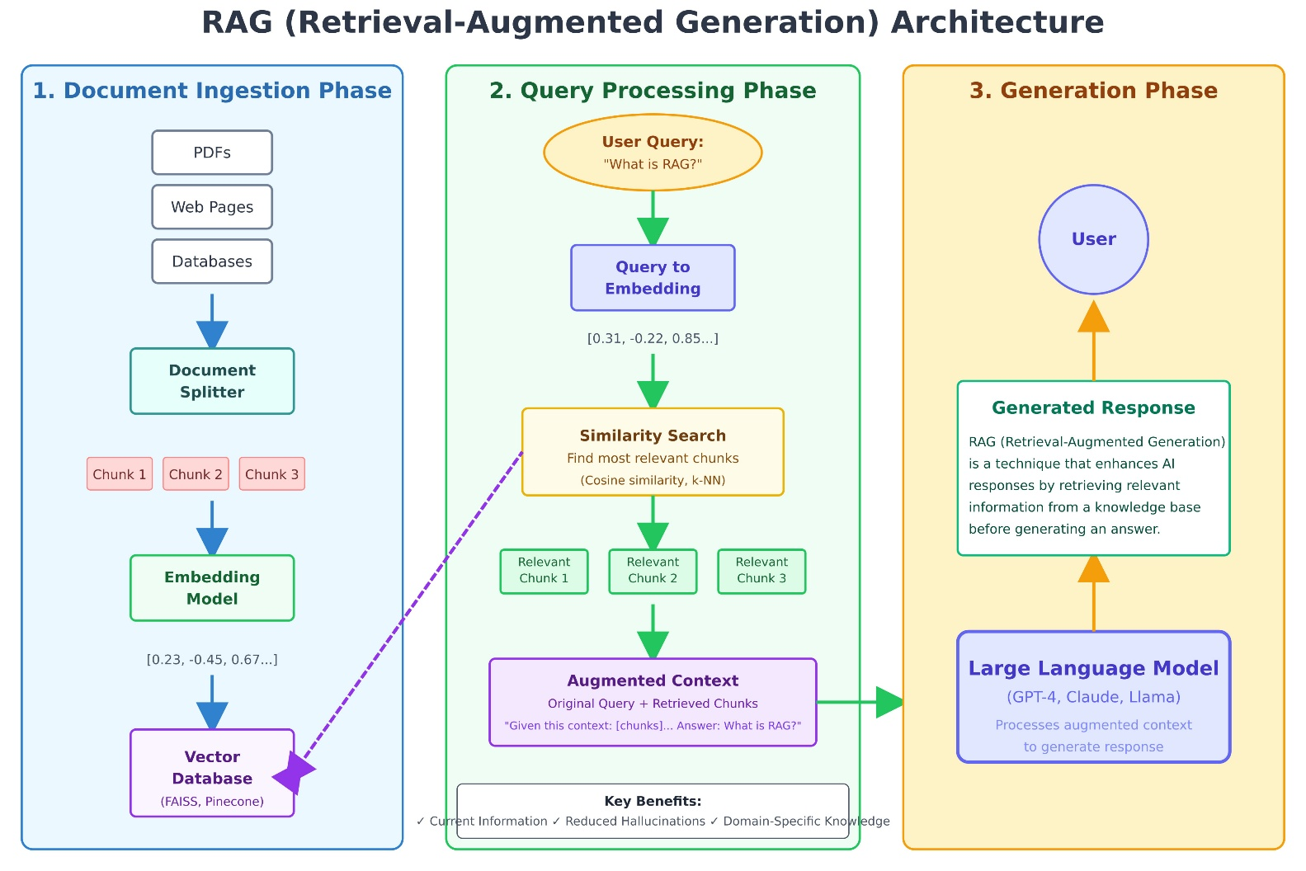
Fig. 1 General RAG pipeline.

- RAG-Based Approach for Agricultural Scheme Information Systems
The choice of Retrieval-Augmented Generation (RAG) over standalone language models is based on the need for accurate and reliable information in agricultural subsidy systems.
• Accuracy: Fine-tuned language models may generate plausible but incorrect responses because they rely on internal training data. RAG improves reliability by grounding responses in official government documents, ensuring factual correctness.
• Traceability: Standalone language models function as black-box systems with no clear source references. RAG enables explainable responses by linking answers to official scheme documents, which helps build user trust.
• Updates: Agricultural scheme guidelines change frequently. Fine-tuned models require retraining to incorporate updates, whereas RAG systems can be updated simply by modifying the document database.
• Cost: Fine-tuning and maintaining language models requires significant computational resources. RAG-based systems are more efficient since they rely mainly on document storage and retrieval.
Overall, RAG prioritizes faithfulness over fluency, making it more suitable for agricultural subsidy information systems where accuracy and reliability are essential.
- System architecture
The proposed system architecture has been designed in a modular layered manner, aimed at ensuring scalability, transparency, and controlled behaviour in a governance-sensitive domain.

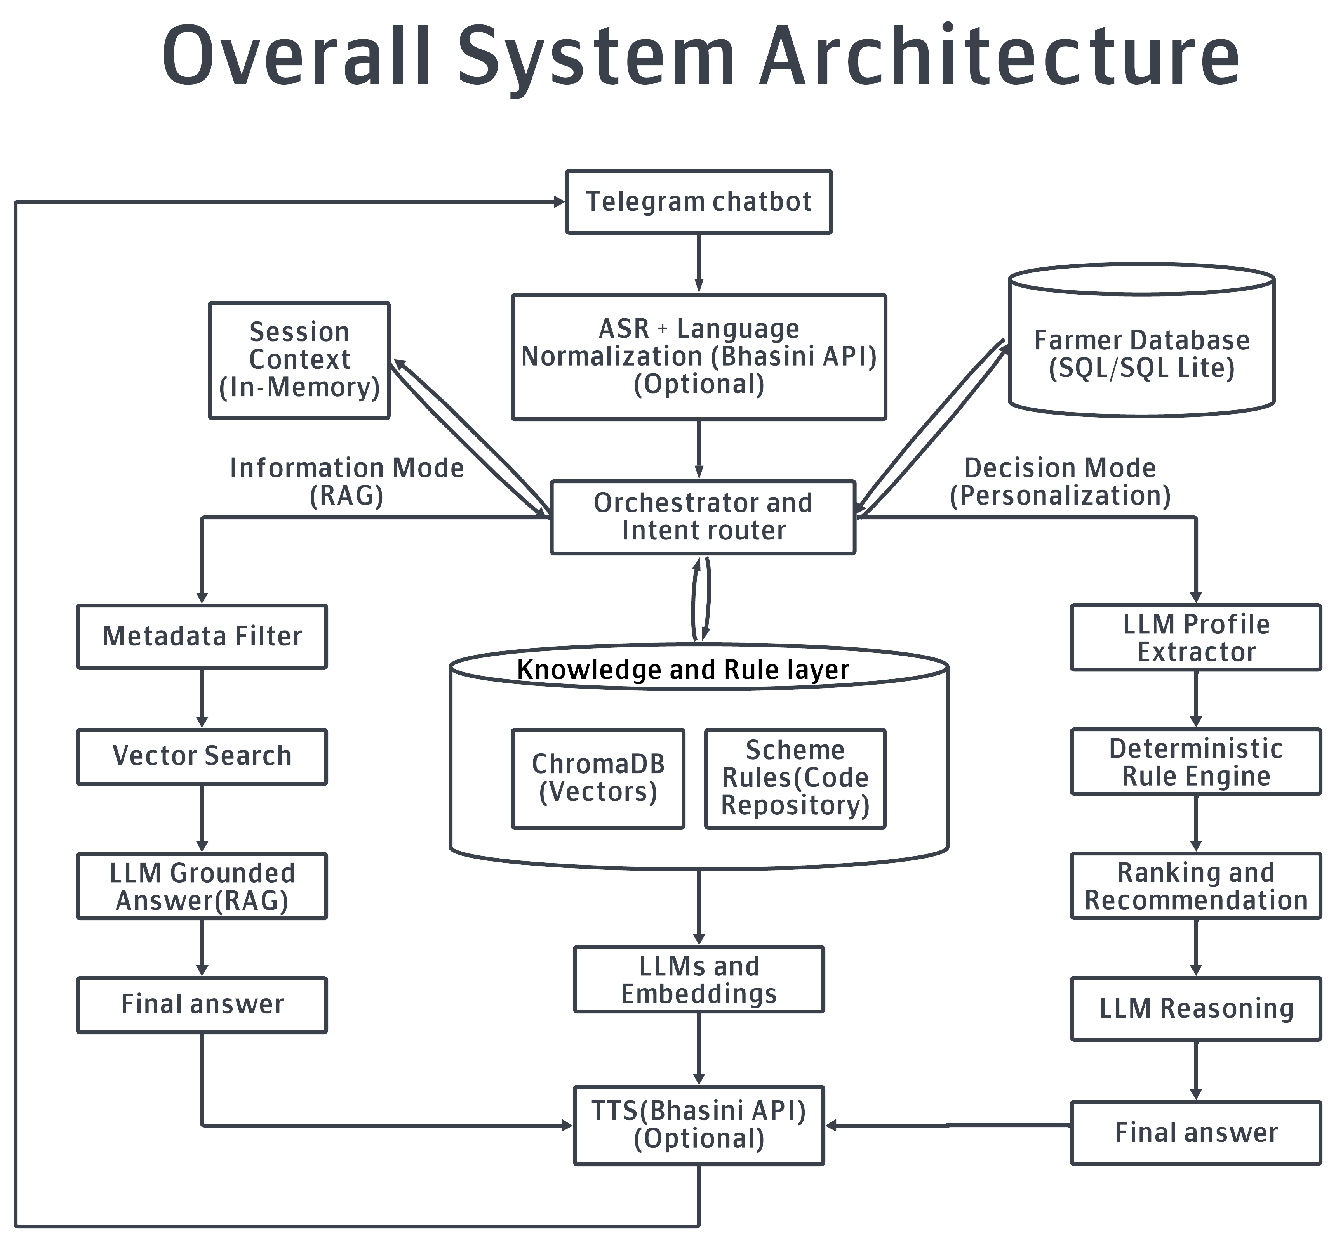
Fig. 2. The architecture of the proposed system

Architectural Layers
1. User Interaction Layer:
Farmers will interact with the system using a conversational interface through text or voice. Telegram is considered the most suitable channel for interaction since it has a large user population and thus, low bandwidth and multilingual communication capacity.
2. Language and Voice Processing Layer:
Speech processing, translation and text-to-speech functions will be offered in this layer. The way it would work is that user queries would be converted into English for backend processing and then translated back to the user's language for a generated response. While the proposed system does foresee integration with the Bhashini platform, in its current articulation, it uses Google Speech Recognition and Google Text-to-Speech services.
3. RAG-based Intelligence Layer Processing:
An RAG pipeline underpins the intelligence layer. User inquiries for scheme relevance and intent are first analyzed, and then relevant document chunks are retrieved from the vector database. The contents retrieved are bounded by a context that contains information for the language model to create answers, which are strictly tied to the official sources. Where relevant information cannot be found, the system will explicitly fall back with a message that indicates the information is not present in official guidelines.
This layer is purposefully limited to information retrieval only, without any eligibility decisions or advisory recommendations.
4. Knowledge and Data Layer:
This layer contains authoritative data, such as the government official scheme guidelines and curated summary documents. The pre-processing, chunking, embedding, and storage of these documents in the vector database will be done with the corresponding metadata for precise retrieval at the whole lifecycle level.
5. Application and integration layer:
This layer contains the bot handling the Telegram bot logic, sessions handling, as well as ASR/TTS services integration and overall orchestration in the system.
The proposed architecture contained the information mode as well as the decision/advisory mode. However the implemented system is constrained to information mode only. The information mode implementing RAG retrieval, multilingual interaction, and Telegram deployment is what the currently working architecture has. Decision support and personalization will be added later. The system is built on trustworthy over completeness, transparent over automation, accessible over complex ones, and as such, meant to act as a trusted information assistant rather than an autonomous decision-making system.
- Methodology
This section describes the methodology used to develop the proposed Retrieval-Augmented Generation (RAG) system, including the data sources, technology stack, document processing pipeline, and retrieval–generation workflow. The methodology emphasizes reliability, traceability, and controlled information access, consistent with the system’s role as an informational assistant rather than a decision-making system.
- Data Sources
The performance of a Retrieval-Augmented Generation system depends strongly on the quality and reliability of its data sources. Since the system is intended for governance-related information access, only authoritative and publicly available documents were used.
The primary data sources include:
• Official operational guidelines for major agricultural schemes such as PM-KISAN, PMFBY, PMKSY, PM-KMY, KCC, and RWBCIS obtained from government portals in PDF format.
• Curated summary documents prepared from official guidelines to consolidate information distributed across lengthy policy documents.
Only officially published documents were included to ensure factual correctness and reduce ambiguity.
Initial experiments using only official PDF guidelines revealed practical limitations such as fragmented retrieval and incomplete responses. Policy documents often contain information distributed across multiple sections, tables, and annexures, making it difficult to retrieve complete context from individual document chunks.
To address this limitation, concise summary documents were created from official guidelines. These summaries preserve the original meaning while presenting information in a structured and retrieval-friendly format. During retrieval, summary documents are prioritized for clarity, while official guideline documents are retained as authoritative reference sources.
The dataset is limited to scheme-level policy information and does not include dynamic farmer-specific data such as land records, income details, or real-time eligibility information. This design decision supports the system’s objective of providing reliable information without performing personalized decision-making.
- Technology Stack
The system was implemented in Python using a modular architecture designed for document ingestion, semantic retrieval, and response generation.
The key technologies used include:
• ChromaDB for vector storage and semantic retrieval
• Sentence Transformers (BAAI/bge-m3) for generating dense vector embeddings
• Groq-hosted LLaMA-based language model for response generation
• Telegram Bot API for user interaction
• Google Speech Recognition and Text-to-Speech for voice-based interaction
• LangChain utilities for document processing and chunking
All components operate within a unified backend environment, ensuring consistent behavior across ingestion, retrieval, and generation stages.
- Data Processing and Ingestion
All documents undergo a standardized preprocessing pipeline before being stored in the knowledge base.
The preprocessing steps include:
• Text extraction from PDF and DOCX documents
• Cleaning and normalization of extracted text
• Logical segmentation into document chunks
• Assignment of metadata such as scheme name, document type, and section context
• Conversion of chunks into vector embeddings
• Storage of embeddings in the vector database
Instead of simple fixed-length segmentation, a two-stage chunking strategy was used to improve contextual completeness.
During initial chunking, documents are divided into overlapping segments to preserve continuity of text. In the chunk consolidation stage, smaller adjacent chunks are merged, particularly for PDF documents, in order to reduce fragmentation of policy clauses and improve retrieval accuracy.
Each document chunk is stored with structured metadata including scheme name, document type, source document, and section-related information. This metadata supports section-aware retrieval and maintains separation between summary documents and official guidelines.
This processing strategy improves retrieval quality while ensuring that generated responses remain grounded in official documentation.
- Retrieval and Generation Pipeline
The system follows a retrieval-first pipeline designed to produce accurate and verifiable responses.
The process begins when a user submits a query through the Telegram interface in either text or voice format. Voice inputs are converted into text using speech recognition, and non-English queries are translated into English for consistent backend processing.
The normalized query is converted into a vector embedding and used to retrieve semantically relevant document chunks from the vector database.
The retrieval process:
• Searches both summary and official guideline documents
• Applies metadata-based filtering for scheme identification
• Uses section-aware ranking to improve alignment with query intent
• Retrieves neighboring chunks when necessary to preserve context continuity
Summary documents are prioritized for readability, while official guidelines provide verification and completeness. Duplicate chunks are removed before context construction.
Retrieved chunks are assembled into a bounded context window before being passed to the language model. Chunks are ordered deterministically, repeated content is removed, and context length is controlled to maintain response clarity. If no relevant information is retrieved, the system returns a fallback response indicating that the information is not available in official guidelines.
The assembled context is then passed to the language model with strict instructions that enforce controlled behavior. The generation process:
• Uses only retrieved information
• Avoids inference and speculation
• Provides fallback responses when information is missing
• Maintains separation between informational and advisory responses
The language model functions as a controlled extractor and formatter rather than an autonomous decision-making system.
Generated responses are translated back into the user's selected language when required. For voice interaction, responses are converted into speech before being delivered through the Telegram interface.
- Results and evaluation
The implemented system was evaluated using two complementary evaluation strategies:
A. A controlled offline query-based evaluation using a predefined set of 30 queries
B. An interactive real-world evaluation through a Telegram-based conversational interface.
The objective of this evaluation was to assess faithfulness, coverage, and robustness in accessing official scheme information, rather than just conversational fluency.
- Observed Successful Behaviour
• The system performed reliably when queries were clearly written and referred to specific schemes such as PM-KISAN or PMFBY. In such cases, responses were accurate and based on official guidelines.
• Scheme overview questions (e.g., basic scheme descriptions and objectives) were handled consistently, with the system retrieving relevant information and generating clear explanations.
• Eligibility and exclusion-related queries were answered correctly when the information was explicitly available in the documents, showing effective use of document-based retrieval.
• Document-related queries were handled appropriately, and the system returned correct fall back responses when specific information was not mentioned in the guidelines.
• During Telegram-based testing, text queries in English generally produced stable and useful responses for eligibility, benefits, and application-related questions.
• The system avoided hallucination by relying on retrieved content and clearly indicating when information was not available, which improved reliability.
• Overall, the retrieval-first design ensured that responses remained grounded in official sources rather than assumptions.
- Observed Limitations
• Some responses were incomplete because policy information is often spread across different sections of long official documents, leading to partial retrieval.
• In certain cases, retrieved PDF sections contained only part of the required information, which resulted in answers that did not fully cover the query.
• Although summary documents were prioritized, PDF content sometimes dominated retrieval due to higher similarity scores, which occasionally reduced response clarity.
• The system showed sensitivity to scheme name variations; small differences in spelling or formatting sometimes affected retrieval accuracy.
• Some responses contained either slightly more or slightly less information than intended due to chunk-level retrieval boundaries.
• Voice-based interaction in Hindi and Gujarati showed higher error rates because speech recognition and translation sometimes altered the original query meaning.
• Spoken scheme names were sometimes not correctly recognized, leading to incorrect or missing scheme identification.
• In a few multilingual cases, information from similar schemes appeared together due to semantic similarity and translation ambiguity.
• These limitations mainly arise from document structure, speech recognition, and multilingual processing rather than errors in the retrieval system itself.
• Despite these issues, the system consistently prioritized factual correctness and avoided generating unsupported information.
- Limitations and future enhancement
- Limitations
• Unstructured Policy Documents: Government scheme documents do not follow a consistent format. Information about eligibility, exclusions, and benefits is often spread across different sections or written under unexpected headings. Because of this, the system sometimes retrieves only part of the relevant information, leading to incomplete responses.
• Summary–PDF Retrieval Trade-off: Although curated summaries are given higher priority during retrieval, sections from official PDFs occasionally dominate because of higher semantic similarity. When this happens, responses may reflect the fragmented structure of policy documents and become less clear.
• Lack of Conversational Memory: The current system operates independently for each query and does not retain conversational context. As a result, follow-up questions or multi-step interactions are not supported.
• Limited Scheme Coverage: The system currently focuses only on major central government schemes. State-level schemes were not included due to the absence of standardized and reliable documentation.
• Restricted Document Formats: Only digitally readable PDF documents were used as data sources. Scanned or image-based documents were excluded in order to avoid errors that could arise from optical character recognition.
• No Personalization Support: The system is designed as an information assistant and does not perform user-specific eligibility checks or personalized recommendations. Farmer profiles, land ownership variations, and individual conditions are therefore not considered.
• No Scheme Comparison Functionality: The system does not support comparisons between schemes, since such functionality would require interpretive or advisory reasoning beyond simple information retrieval.
- Future Work
• Integration of Structured Information Sources: Structured platforms such as myscheme.gov.in can be incorporated as additional data sources. Using structured information alongside policy documents could improve consistency and coverage.
• Improved Document Structuring: Future work can focus on converting policy documents into structured formats such as JSON or XML with clearly labelled sections. This would reduce dependence on heuristic extraction methods and improve retrieval accuracy.
• Expansion to State-Level Schemes: The system can be extended to include state government schemes once reliable and standardized documentation becomes available.
• Support for Scanned Documents: Incorporating OCR pipelines would allow the system to process scanned policy documents that are currently excluded.
• Improved Language Support: Integration with national language platforms such as Bhashini could improve speech recognition, translation accuracy, and support for regional dialects.
• Conversational Interaction: Introducing limited conversational memory would allow the system to handle follow-up questions while still maintaining its non-advisory design.
• Multi-Scheme Queries: Future versions could support queries involving multiple schemes by presenting clearly separated information without introducing advisory comparisons.
• Farmer-Centric Personalization: With appropriate safeguards, future versions could include farmer-specific information such as landholding size, crop patterns, or regional conditions to provide more relevant guidance while remaining informational rather than decision-making.
- Conclusion
This study demonstrates the practical feasibility of using a Retrieval-Augmented Generation (RAG)–based approach to provide reliable and verifiable access to information on Indian government agricultural schemes. By grounding responses in official guidelines and curated summaries, the system addresses several limitations of existing information portals and standalone language models, particularly issues related to inaccurate responses, lack of transparency, and difficulty in locating relevant scheme information.
The system was designed with a strong emphasis on factual correctness rather than conversational fluency. Responses are generated only when supported by official documents, and clear fall back messages are provided when information is not available. Through structured document ingestion, metadata-based organization, and controlled retrieval strategies, the system is able to navigate complex and fragmented policy documents with reasonable consistency. The implementation of a multilingual Telegram interface further demonstrates how such systems can be deployed in practical farmer-facing environments using platforms that users are already familiar with.
The evaluation highlights both the strengths and the current limitations of the approach. The system performs reliably for clearly phrased text queries and major central government schemes, but challenges remain due to the unstructured nature of policy documents and the variability introduced by multilingual speech interaction. Importantly, these limitations result primarily in incomplete responses rather than incorrect ones, reflecting the system’s design goal of prioritizing reliability over speculation.
Overall, the work establishes a foundation for developing trustworthy digital assistants for agricultural governance. By separating information retrieval from decision-making and focusing on verifiable responses, the proposed framework offers a practical approach for improving farmers’ access to scheme-related information. With further improvements in document structuring, multilingual interaction, and integration of additional data sources, such systems have the potential to reduce information gaps and make government support mechanisms more accessible to farmers.
References
[1] ForumIAS, "Farm Subsidies in India," 2024. [Online]. Available: https://forumias.com/blog/farm-subsidies-in-india/
[2] Drishti IAS, "Rationalizing Subsidies in India," 2024. [Online]. Available: https://www.drishtiias.com/daily-updates/daily-news-editorials/rationalizing-subsidies-in-india
[3] Biothink, "Biothink Research Report 2025," 2025. [Online]. Available: https://biothink.in/wpcontent/uploads/2025/01/biothink-2025-16-updated.pdf
[4] REST Publisher, "The Role of Subsidies in Shaping Indian Agriculture: An Economic Perspective," 2025. [Online]. Available: https://restpublisher.com/wp-content/uploads/2025/04/24.-The-Role-of-Subsidies-in-Shaping-Indian-Agriculture-An-Economic-Perspective.pdf
[5] Ministry of Agriculture and Farmers Welfare, Government of India, "Agricultural Census 2015–16," 2016. [Online]. Available: https://agcensus.da.gov.in/document/agcen1516/ac_1516_report_final-220221.pdf
[6] Drishti IAS, "Reforming Agricultural Subsidies," 2025. [Online]. Available: https://www.drishtiias.com/daily-updates/daily-news-analysis/reforming-agricultural-subsidies
[7] "Agricultural Subsidies and Their Impact on Indian Agriculture," International Journal of Creative Research Thoughts (IJCRT), 2024. [Online]. Available: https://ijcrt.org/papers/IJCRT2507067.pdf
[8] Rang De, "Understanding Farm Subsidies," 2024. [Online]. Available: https://rangde.in/blog/understanding-farm-subsidies
[9] Ministry of Agriculture and Farmers Welfare, Government of India, "Agriculture Infrastructure Fund: Scheme Guidelines," 2023. [Online]. Available: https://agriinfra.dac.gov.in/Content/DocAttachment/FINALSchemeGuidelinesAIF.pdf
[10] International Institute for Sustainable Development (IISD), "Agricultural Subsidies in India," 2024. [Online]. Available: https://www.iisd.org/articles/policy-analysis/agricultural-subsidies-india
[11] B. Mannepalli, "Analysis of Growth Rates of Agricultural Subsidies and Capital Formation in the Agriculture Sector of India," 2023. [Online]. Available: https://www.researchgate.net/profile/Bharath-Mannepalli/publication/385208411
[12] A. Alawode, "Evaluating Agricultural Subsidy Reforms and Their Effects on Smallholder Farmer Income and Efficiency," 2024. [Online]. Available: https://www.researchgate.net/profile/Adedapo-Alawode/publication/392066960
[13] "Agricultural Subsidies in India: Boon or Curse," 2024. [Online]. Available: https://d1wqtxts1xzle7.cloudfront.net/34632801/Agricultural_subsidies_in_India_-_boon_or_curse-libre.pdf
[14] H. A. Salunkhe, "Impact of Subsidy on Agriculture Sector," 2023. [Online]. Available: https://d1wqtxts1xzle7.cloudfront.net/33627301/2._Agri_-_Impact_-_HArshal_Anil_Salunkhe-libre.Pdf
[15] "Impact of Subsidies on Indian Agriculture," 2024. [Online]. Available: https://d1wqtxts1xzle7.cloudfront.net/65214350/Impact_of_subsidies_on_indian_agriculture-libre.pdf
[16] "Agricultural Subsidies and Policy Implications in India," SSRN Research Paper, 2024. [Online]. Available: https://papers.ssrn.com/sol3/papers.cfm?abstract_id=4555039
[17] "Evaluating Agricultural Subsidy Impacts on Environmental and Economic Outcomes," Current World Environment, vol. 19, no. 1, pp. 393–403, 2024. [Online]. Available: https://www.cwejournal.org/pdf/Vol19No1/CWE_Vol19_No1_p_393-403.pdf
[18] "Retrieval-Augmented Generation Based Information Systems," International Journal of Advanced Research in Computer and Communication Engineering, 2025. [Online]. Available: https://ijarcce.com/wp-content/uploads/2025/05/IJARCCE.2025.14518.pdf
[19] India Digital Summit, "Led by Surge in Indic Language Adoption," 2025. [Online]. Available: https://www.indiadigitalsummit.in/wp-content/uploads/2025/01/Led-by-Surge-in-Indic-Language-Adoption.pdf
[20] Economic Times Telecom, "Targeted Interventions to Bridge India’s Urban–Rural Teledensity Gap," 2024. [Online]. Available: https://telecom.economictimes.indiatimes.com/news/policy/targeted-interventions-to-bridge-indias-urban-rural-teledensity-gap/124385619
[21] Centre for Economic Data and Analysis (CEDA), Ashoka University, "One Nation, Many Disconnects: Mapping India’s Home Internet Gaps," 2024. [Online]. Available: https://ceda.ashoka.edu.in/one-nation-many-disconnects-mapping-indias-home-internet-gaps/
[22] "Digital Buying Behaviour among Farmers," International Journal of Innovative Science and Engineering Management, 2024. [Online]. Available: https://ijisem.com/journal/index.php/ijisem/article/download/377/349
[23] OpenSignal, "India Mobile Network Experience Report," 2024. [Online]. Available: https://www.opensignal.com/reports/2024/10/india/mobile-network-experience
[24] VoiceSpin, "Voice AI Latency Explained," 2024. [Online]. Available: https://www.voicespin.com/blog/voice-ai-latency-explained/
[25] World Economic Forum, "AI for Agriculture in India," 2024. [Online]. Available: https://www.weforum.org/impact/ai-for-agriculture-in-india/
[26] M. Kumar and P. Singh, "Agro-Franchising for Farm Input and Market Linkage Delivery: A Case Study of DeHaat in Bihar," 2025. [Online]. Available: https://www.researchgate.net/publication/394431759
[27] Design Studio UI/UX, "Agriculture Farming App Design Case Study," 2024. [Online]. Available: https://www.designstudiouiux.com/case-study/agriculture-farming-app-design/
[28] M. Thirupathy, "Designing for India’s Farmers with Low Digital Literacy," 2024. [Online]. Available: https://medium.com/@maddiethirupathy/designing-for-indias-farmers-with-low-digital-literacy-867eddb0474
[29] "Awareness and Adoption of Agricultural Schemes among Farmers," International Journal of Advanced Research, 2025. [Online]. Available: https://www.journalijar.com/uploads/2025/03/67ef8e82ba4c4_IJAR-50822.pdf
[30] J. D. Borrero and J. Mariscal, "A Case Study of a Digital Data Platform for the Agricultural Sector," Agriculture, vol. 12, no. 6, p. 767, 2022. [Online]. Available: https://www.mdpi.com/2077-0472/12/6/767
[31] World Economic Forum, "Farmers in India Are Using AI for Agriculture – Here’s How They Could Inspire the World," 2024. [Online]. Available: https://www.weforum.org/stories/2024/01/how-indias-ai-agriculture-boom-could-inspire-the-world/
[32] CensaNext REAP, "Cultivating the Future: Bridging the Digital Divide in Indian Agriculture," 2024. [Online]. Available: https://www.reap.censanext.com/Case-Studies/cultivating-the-future-bridging-the-digital-divide-in-indian-agriculture
[33] "Digital Literacy Among Rural Farmers: A Study," 2024. [Online]. Available: https://www.researchgate.net/publication/371839684
[34] "Adoption of Digital Technologies in Agriculture," Journal of Extension Education, 2024. [Online]. Available: https://www.extensionjournal.com/article/view/1503/S-7-12-29
[35] Press Information Bureau, Government of India, "Universal Connectivity and Digital India Initiatives Reaching All Areas Including Tier-2/3 Cities and Villages," 2024. [Online]. Available: https://www.pib.gov.in/PressReleasePage.aspx?PRID=2040566
[36] Ministry of Agriculture and Farmers Welfare, Government of India, "Digital Agriculture Division," 2024. [Online]. Available: https://agriwelfare.gov.in/en/DigiAgriDiv
[37] Geospatial World, "Case Study: Can Digital Technologies Rescue Sinking Farmers," 2024. [Online]. Available: https://geospatialworld.net/gsi/blogs/blog-detail.php?id=339
[38] P. Lewis et al., "Retrieval-Augmented Generation for Knowledge-Intensive NLP Tasks," Advances in Neural Information Processing Systems, vol. 33, 2020.
[39] Google, "Gemini," 2025. [Online]. Available: https://gemini.google.com
[40] OpenAI, "ChatGPT," 2025. [Online]. Available: https://chatgpt.com
[41] IBM, "RAG vs Fine-Tuning vs Prompt Engineering," 2024. [Online]. Available: https://www.ibm.com/think/topics/rag-vs-fine-tuning-vs-prompt-engineering
[42] Google Cloud, "Fine-Tuning AI Models," 2024. [Online]. Available: https://cloud.google.com/use-cases/fine-tuning-ai-models
[43] KDNuggets, "Top 5 Embedding Models for Your RAG Pipeline," 2024. [Online]. Available: https://www.kdnuggets.com/top-5-embedding-models-for-your-rag-pipeline
[44] M. R. Ameen, A. Islam, F. Aktar, and M. S. Rafat, "KrishokBondhu: A Retrieval-Augmented Voice-Based Agricultural Advisory Call Center for Bengali Farmers," 2025.
[45] S. Gupta, R. Ranjan, and S. N. Singh, "A Comprehensive Survey of Retrieval-Augmented Generation (RAG): Evolution, Current Landscape and Future Directions," 2024.

